Step050. How to balance between energy saving and comfortable temperature

Note.
If we get more data about weather historical and the details of heater usage, we may be able to use energy more effectively.

%%%%%%%%%%%%%%%%%%%%%%%%%%%%%%%%%%%%%%%%%%%%%%%%%%%%%%%%%%%%%%%%%%%%%%%%%%%%%%%
(01).
For date j in calendar, the temperature is c(j) when no heater (natural temperature).
Suppose the 5 rooms have heaters with w(j, 1), w(j, 2), …, w(j, 5) Watt for date j in calendar. For example, w(10November2017, 3) may be equal to 1500W.
This means, to reach a comfortable temperature, the number of Watt of heater can be adjusted (automatically).
For room k, its heater can make temperature increasing for b(k)*w(j, k) Celsius. Different heater has different coefficient b(k), because the rooms are different, some rooms may have bigger size.
In big room, heater is not same powerful as in small room.
Suppose for room k at date j, the actual temperature is t(j, k), we may think:
t(j, k) = c(j) + b(k)*w(j, k) + e(j, k)
In the formula, e(j, k) is error, that may come from many random factors. For example, for some rooms at some special dates, patients are more than usual, the room doors are opened and closed frequently, this may affect the actual temperatures.

%%%%%%%%%%%%%%%%%%%%%%%%%%%%%%%%%%%%%%%%%%%%%%%%%%%%%%%%%%%%%%%%%%%%%%%%%%%%%%%
(02).
The Figure 02.1 lists the average temperature in capital city Rome in Italy.
If we have more accurate weather historical data, we can improve our results.
So, we will set all c(j) to 17 if the date j falls in October, and so on.
For any fixed k and those j within same month, w(j, k) will keep constant.

Figure 02.1

Month | Tempreture
10 | 17
11 | 12
12 | 8
1 | 8
2 | 8

%%%%%%%%%%%%%%%%%%%%%%%%%%%%%%%%%%%%%%%%%%%%%%%%%%%%%%%%%%%%%%%%%%%%%%%%%%%%%%%
(03).
Using the model in paragraph (01) above, and the data in Excel file “feb tem-2”, we can estimate each of the b(k)*w(j, k), see Figure 03.1 below.
For example, for Room 1 and October, b(1)*w(10, 1) = 3.2129 Celsius.
For example, for Room 4 and February, b(4)*w(2, 4) = 11.822 Celsius.

Figure 03.1

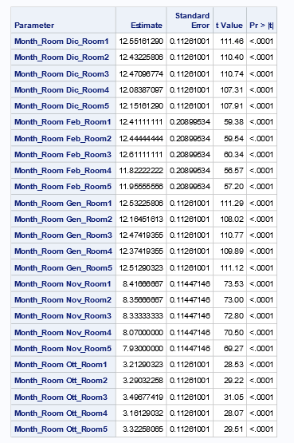

%%%%%%%%%%%%%%%%%%%%%%%%%%%%%%%%%%%%%%%%%%%%%%%%%%%%%%%%%%%%%%%%%%%%%%%%%%%%%%%
(04).
Using the estimated model in paragraph (03) above, the (actual) temperature and the predicted temperature (Predict) are displayed in Figure 04.1 to Figure 04.5 for the 5 rooms.

Figure 04.1. Room 1

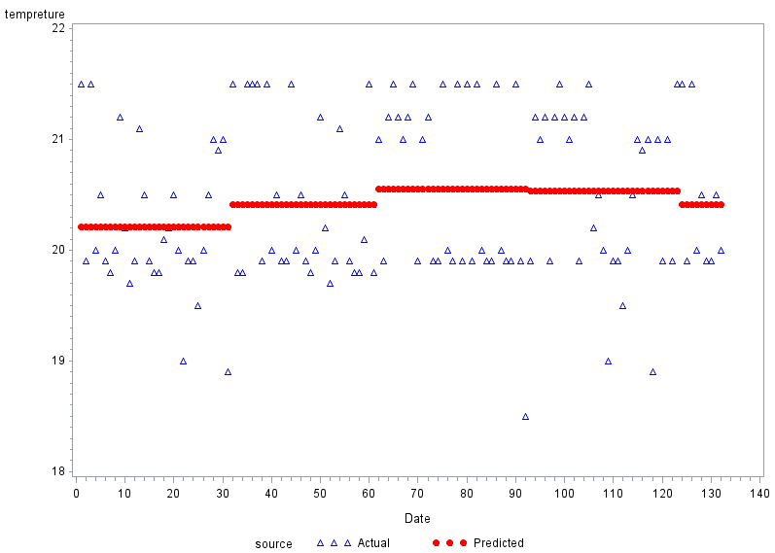

Figure 04.2. Room 2

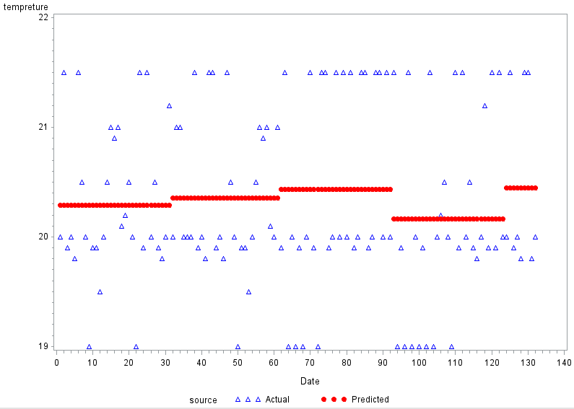

Figure 04.3 Room 3

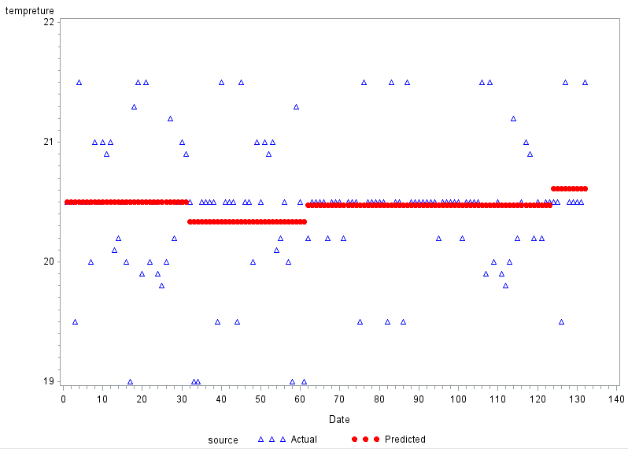

Figure 04.4. Room 4

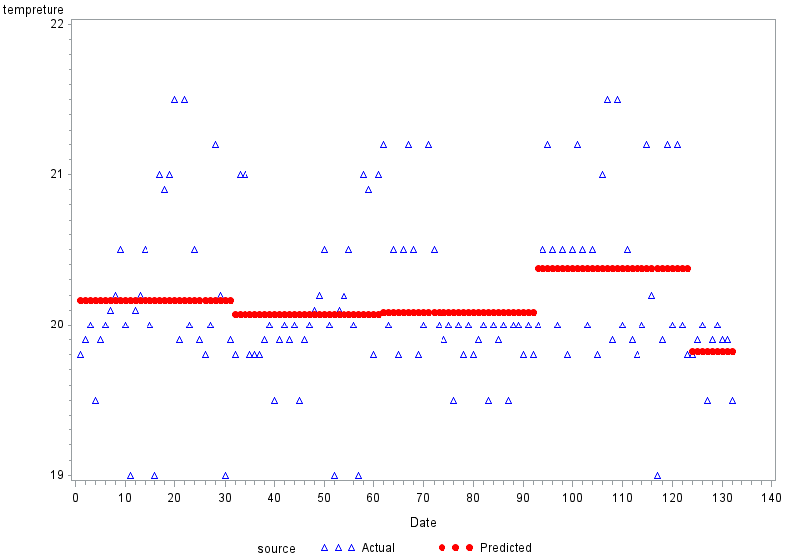

Figure 04.5. Room 5

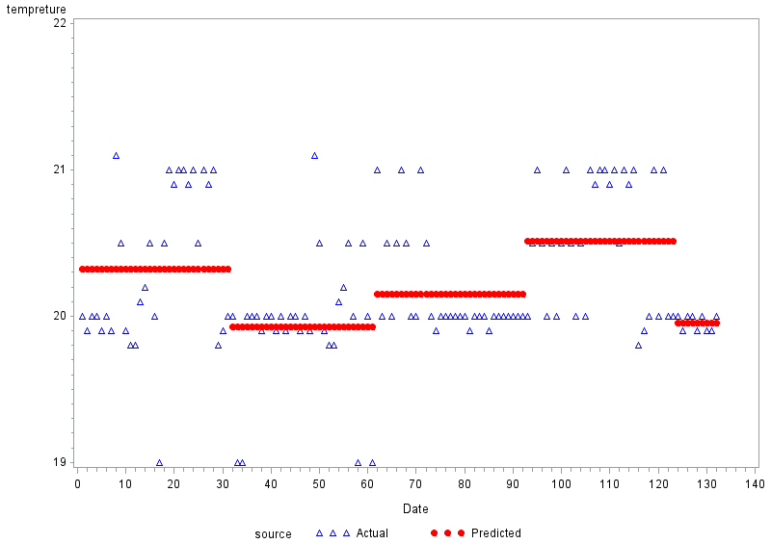

%%%%%%%%%%%%%%%%%%%%%%%%%%%%%%%%%%%%%%%%%%%%%%%%%%%%%%%%%%%%%%%%%%%%%%%%%%%%%%%
(05).

Now let’s see, if we suffer for a temperature one celsius below the current temperature we are enjoying, how much energy we can save.

Let’s check room 1 first.
From Figure 03.1, we can see:
b(1)*w(10, 1) = 3.2129 Celsius.
b(1)*w(11, 1) = 8.416 Celsius.
b(1)*w(12, 1) = 12.55 Celsius.
b(1)*w(1, 1) = 12.532 Celsius.
b(1)*w(2, 1) = 12.411 Celsius.

To be simple, suppose the number of days keeps same in each the 5 months.
The current total energy for room 1 is equal to:
Total1 = (w(10, 1) + w(11, 1) + w(12, 1) + w(1, 1) + w(2, 1) ).

On October, if reducing temperature for one celsius in our air conditioner, we will use energy:
(1 - (1/3.2192))* w(10, 1)
On November, if reducing temperature for one celsius in our air conditioner, we will use energy:
(1 - (1/8.416))* w(11, 1)

And so forth.

Because:
N = (1 - (1/3.2192))*3.2192 + (1 - (1/8.416))*8.416 + (1 - (1/12.55))*12.55+ (1 - (1/12.532))*12.532 +(1 - (1/12.411))*12.411

D = 3.2192 + 8.416 + 12.55+ 12.532 + 12.411

p = 1 - (N/D) = 0.1018

Therefore, if reducing temperature for one celsius in our air conditioner in room 1, we can save 10.18% of the current energy.

So if we are willing to suffer little, we can save big.

In the same way, we can calculate what percentages we can save for the remaining 4 rooms, if reducing temperature for one celsius in the 4 air conditioners.

